
NAME:

11AEMAM Test 4 2021

Section 1: /

Section 2: /

Total: /

%

TIME ALLOCATION FOR THIS TEST

Section 1 – No Calculators Allowed

minutes reading time: 2 minutes
minutes working time: 30 minutes

Section 2 – Calculators allowed

minutes reading time: 1 minutes
minutes working time: 22

Material required/recommended for this test

To be provided by the supervisor
Question/answer booklets for Sections One and Two.
SCSA 11AEMAM Formulae Sheet

To be provided by the candidate

Section One:

Standard items: pens, pencils, pencil sharpener, highlighter, eraser, ruler
Special materials: drawing instruments, templates, notes on a maximum of one unfolded sheet of A4 paper

Section Two:

Standard items: pens, pencils, pencil sharpener, highlighter, eraser, ruler
Special materials: drawing instruments, templates, notes on a maximum of one unfolded sheet of A4 paper, notes on a maximum of one unfolded sheet of A4 paper, up to three approved calculators, CAS, graphics, or scientific.

Important note to candidates

No other items may be taken into the test room. It is your responsibility to ensure that you do not have any unauthorised notes or other items of a non-personal nature in the test room. If you have any unauthorised material with you, hand it to the teacher before reading any further.

Section | Reading Time | Working time | Marks | Score
Resource free | 2 minutes | 30 | 30 | %
Resource rich | 1 minutes | 20 | 21 | %
Total | 3 minutes | 50 | 51 | %
Resource Free: 30 minutes

Question 1 (6 marks)
(a) On the axes below, sketch the graph of $y^{2}=x$, labelling all key features with their coordinates or equations (3 marks)
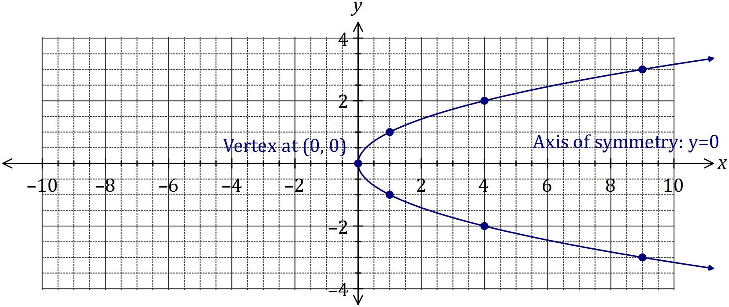
Solution
See graph
Specific behaviours
smooth curve through at least 5 out of 7 marked points
labels vertex
labels axis of symmetry

(b) Determine the equation of the circle shown below (3 marks)
Solution
$${\left(x+2\right)}^{2}+{\left(y-1\right)}^{2}=49$$

Specific behaviours
uses standard form for circle
uses correct centre
uses correct radius
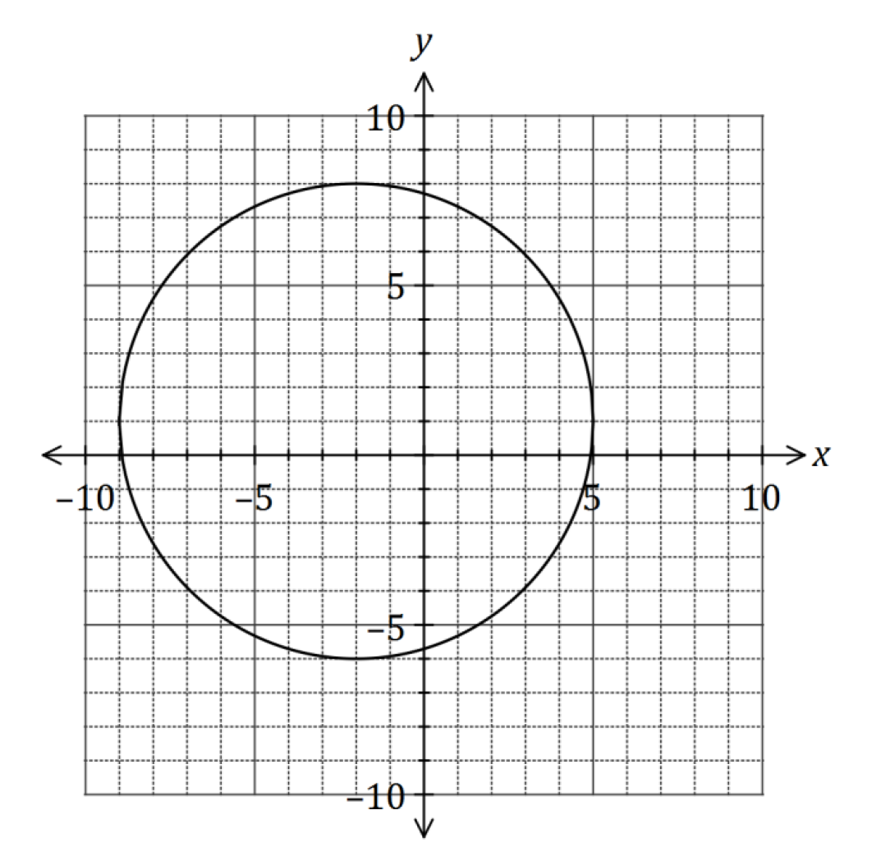

Question 2 (8 marks)
(a) Solve the equation $x^{3}=7x^{2}+30x$ (4 marks)
Solution
$$x^{3}-7x^{2}-30x=0$$
$$x\left(x^{2}-7x-30\right)=0$$
$$x\left(x-10\right)\left(x+3\right)=0$$
$$x=0, x=10, x=-3$$

Specific behaviours
equates to zero
factors out $x$
factors quadratic
states all solutions

(b) The graph of $y=ax^{3}+bx+cx+d$ is shown below. Determine the values of the constants of $a, b, c,$ and $d$. (4 marks)
Solution
$$y=a\left(x+1\right)\left(x-1\right)\left(x-2\right)$$
$$x=0, y=4⇒4=2a, a=2$$
$$y=2\left(x^{2}-1\right)\left(x-2\right)=2\left(x^{3}-2x^{2}-x+2\right)$$
$$a=2, b=-4, c=-2, d=4$$

Specific behaviours
writes factors from roots
determines $a$
expands
states all values
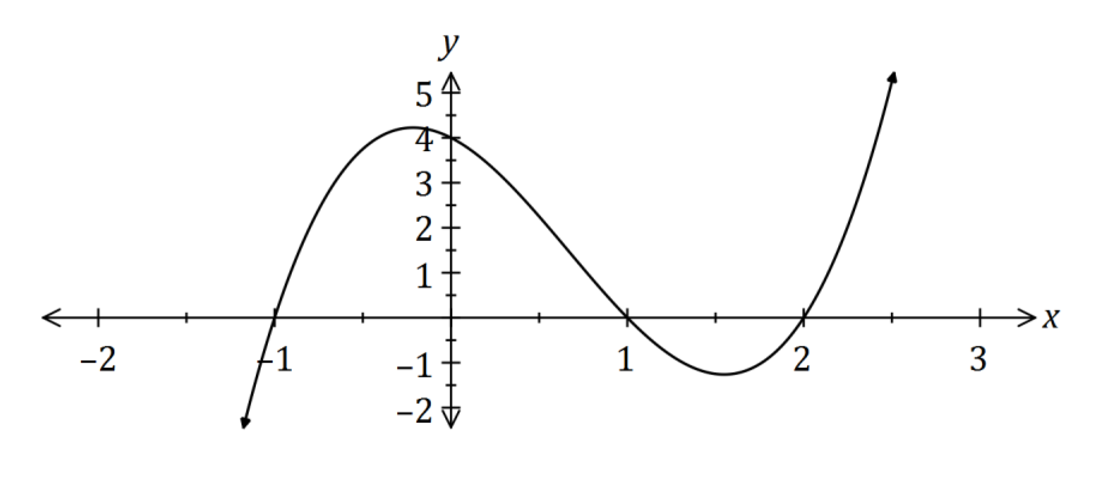

Question 3 (8 marks)
Solution
From 3-4-5 right-triangle, $\cos{β=\frac{4}{5}}$
From 2-$\sqrt{5}$-3 right-triangle, $\sin{α}=\frac{\sqrt{5}}{3}$
Using identity, $\cos\left(α-β\right)=\frac{2}{3}×\frac{4}{5}+\frac{\sqrt{5}}{3}×\frac{3}{5}=\frac{8+3\sqrt{5}}{15}$

Specific behaviours
states $\cos{β}$
states $\sin{α}$
uses identity
simplifies
(a) If $α$ and $β$ are acute angles such that $\cos{α=\frac{2}{3}}$ and $\sin{β=\frac{3}{5}}$, determine the value of $\cos{(α-β)}$ as a single fraction. (4 marks)

(b) Solve the following equations.
(i) $\sqrt{2}\sin{x=-1}$ where $0≤x≤2π$ (2 marks)
Solution
$$\sin{x}=-\frac{1}{\sqrt{2}}$$
$$x=\frac{5π}{4}, x=\frac{7π}{4}$$

Specific behaviours
both solutions located in 3rd and 4th quadrants
correct angles using radians

(ii) $\tan\left(2x\right)=0.4$ where $0≤x≤180°$ given that $\tan{22°}=0.4$ (2 marks)
Solution
$$\tan\left(22°\right)=0.4⇒2x=22°, 2x=22°+180°$$
$$x=11°, x=101°$$

Specific behaviours
first solution
second solution

Question 4 (5 marks)
(a) Find the exact value of $\cos{\frac{13π}{12}}$

END OF SECTION ONE
Calculator Allowed Section Name: …………………………………
Reading time: 1 minutes
Working time: 20 minutes Marks: 21
Question 5 (6 marks)
(a) The graphs of $y=a sin{(x)}, y=\sin{(bx)}, y=d\cos{(x)}$ and $y=\cos{(ex)}$ are shown below.
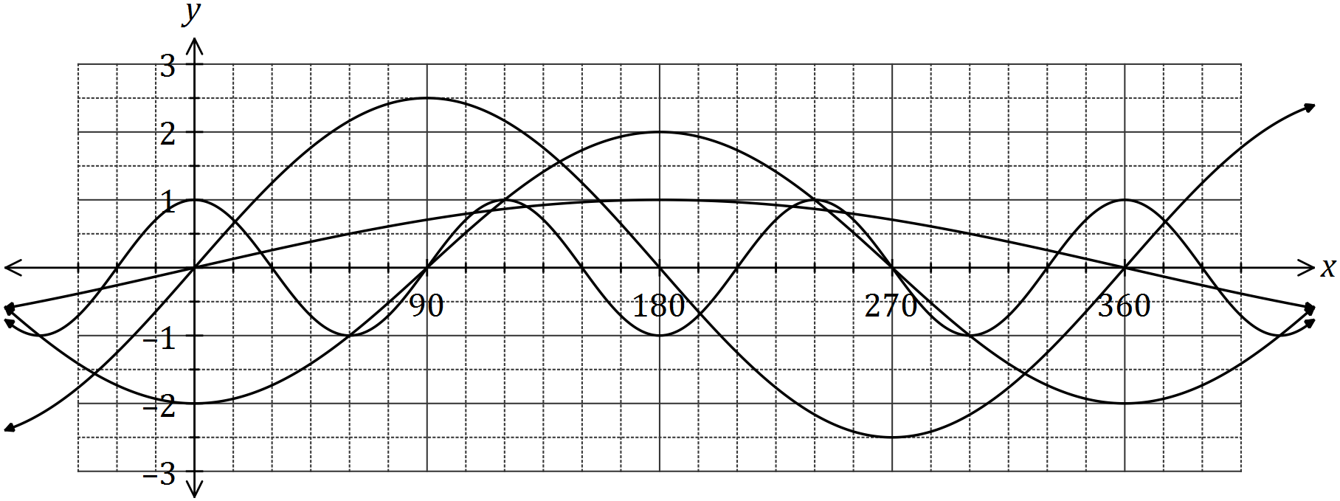
Determine the values of the constants $a, b, d$ and $e$. (4 marks)
Solution
$$a=2.5, b=0.5, d=-2, e=3$$

Specific behaviours
one mark per correct value

(b) The graph of $y=\cos{(x-α)}$ is drawn below.

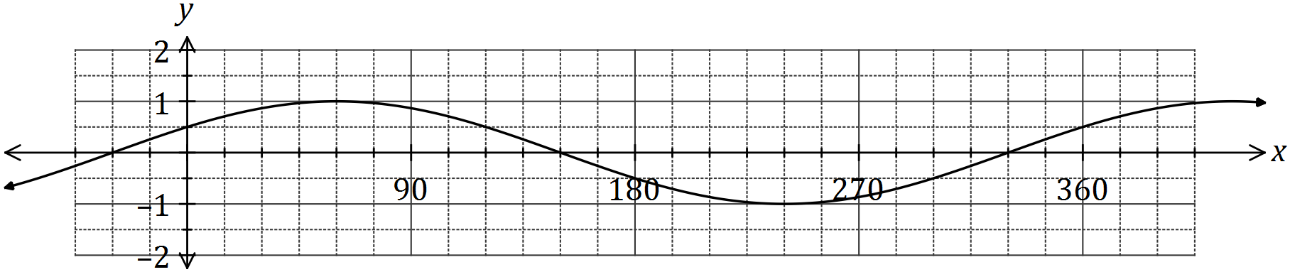

- State the value of the constant $α$, where $0°<α<360°$. (1 mark)
Solution
$$α=60°$$
Specific behaviours
states value

(ii) The graph is also that of $y=\sin{(x+β)}$. State the value of the constant $β$, where
$0°<β<360°$. (1 mark)
Solution
$$β=30°$$
Specific behaviours
states value
Question 6 (7 marks)
Let $f\left(x\right)=\begin{matrix}4 \\ \overline{3-x}\end{matrix}$ and $g\left(x\right)=\begin{matrix}1 \\ \overline{x+p}\end{matrix}+q$, where $p$ and $q$ are constants.

The graph of $y=g(x)$ is shown below.
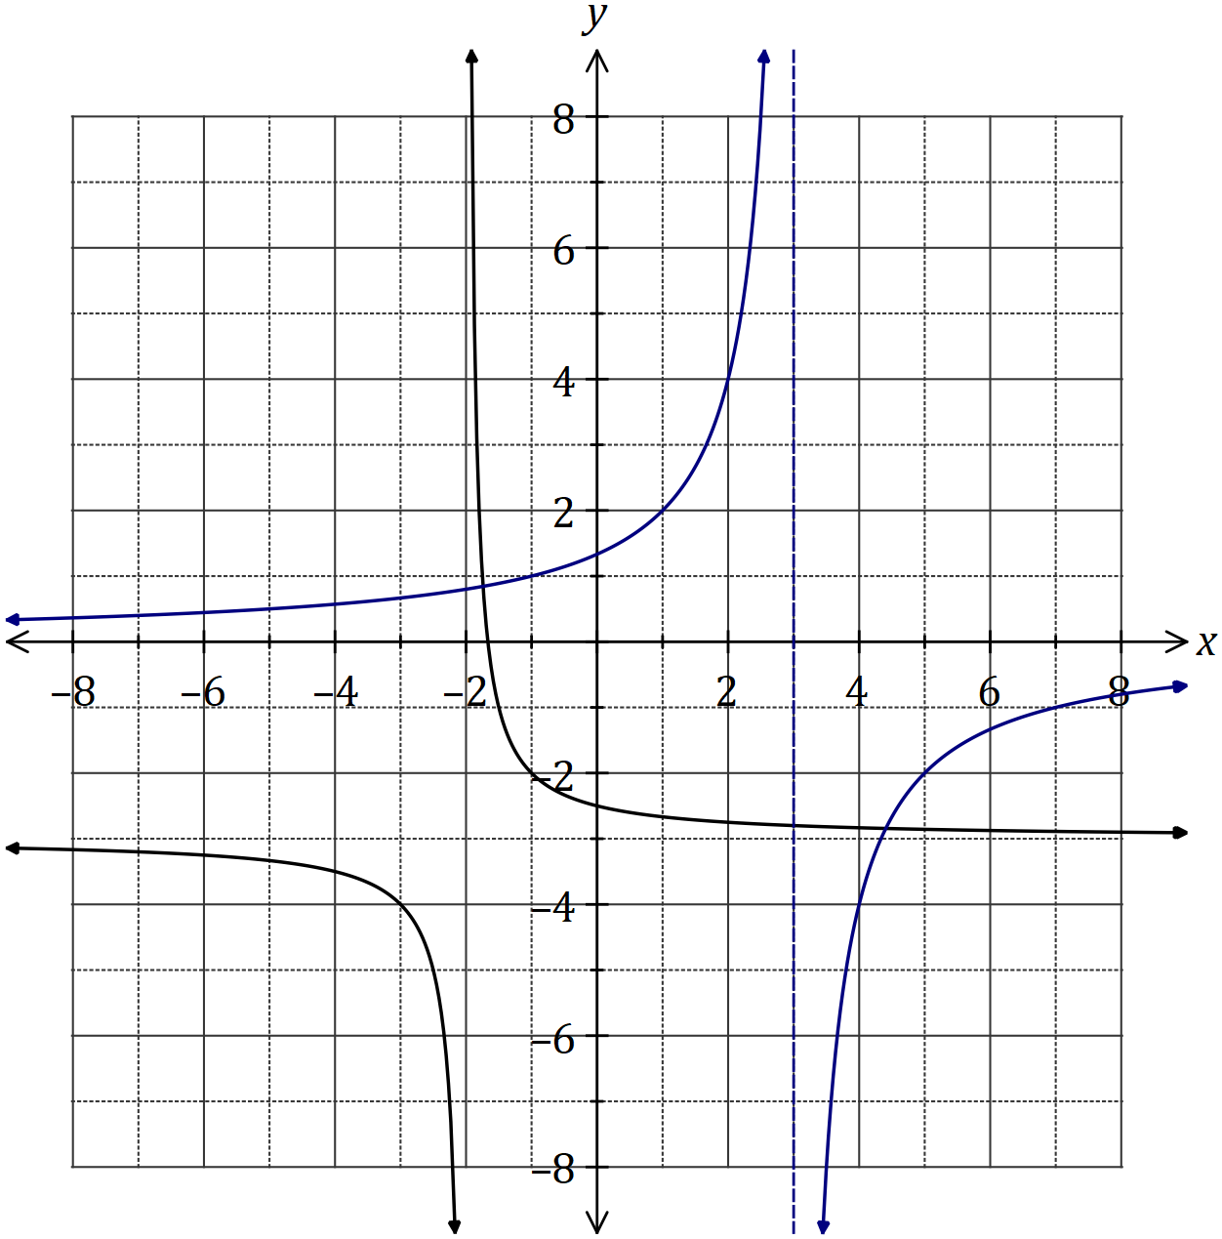
Solution
See graph
Specific behaviours
asymptotes
y-intercept
accuracy [i.e. thru' at least 3 of (-1,1), (1,2), (2,4), (4,-4) or (7,-1)]

(a) Sketch the graph of $y=f(x)$ on the axes above. (3 marks)

(b) Determine the values of $p$ and $q$. (2 marks)
Solution
$$p=2, q=-3$$

Specific behaviours
value of $p$
value of $q$

(c) Solve the equation $f\left(x\right)=g(x)$, giving your solution(s) to one decimal place. (2 marks)

Solution
$$x=-1.7, x=4.4$$

Specific behaviours
one solution
second solution
(Rounding for guidance only but penalise answers given as coordinates)

Question 7 (8 marks)
During 2018, the altitude of the sun, $θ$ degrees, at noon in Melbourne on the $n^{th}$ day of the year can be modelled by the equation

$$θ=23.5\sin\left(\frac{8π\left(101+n\right)}{1461}\right)+52.2$$

(a) On the 26th of January, the altitude was $71.4°$. Calculate the altitude ten days earlier.
(2 marks)
Solution
$$n=16, θ=73.4°$$

Specific behaviours
indicates $n$
correct angle

(b) Graph the altitude on the axes below for $0≤n≤365$. (4 marks)

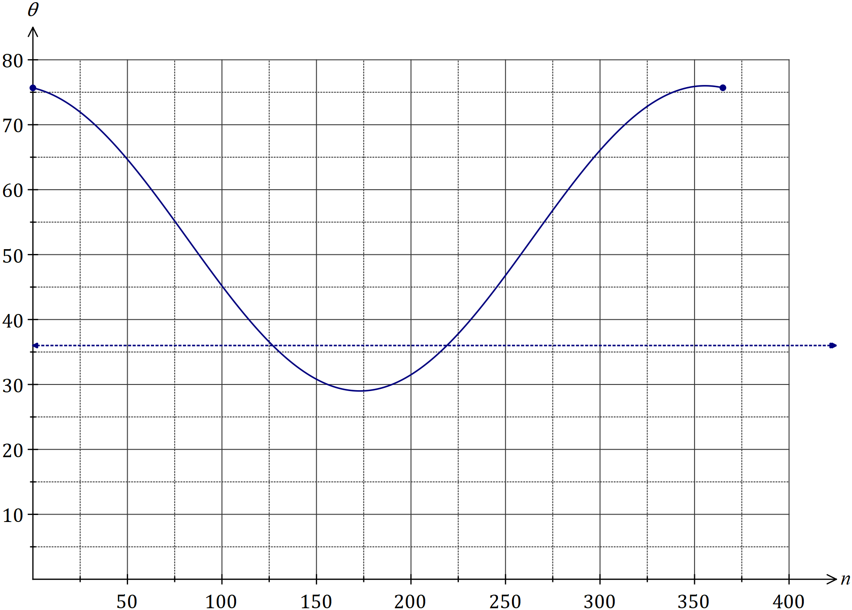

(c) State the minimum altitude of the sun at noon in Melbourne and on which day of the year this occurred. (2 marks)

Solution
$$θ_{MIN}=28.7° \text{on day} 173$$

Specific behaviours
altitude, correct to 1dp
day of year, rounded to whole number

THIS PAGE HAS BEEN LEFT BLANK INTENTIONALLY TO PROVIDE SPACE FOR WORKING IF REQUIRED
END OF TEST

